Creating Your First Macro Microsoft Support
In this sub section, we will show you how to create your first macro (VBA program). We will use the world classic "Hello World!" example. To create the example, please follow the following steps:
1. Open Visual Basic Editor by go to Tools...Macro...Visual Basic Editor or just simply press the [Alt] and [F11] keys at the same time.
2. In the Insert menu on top of the Visual Basic Editor, select Module to open the Module window (code window).
3. In the Module window, type the following:
Sub showMessage()
MsgBox "Hello World!"
End Sub
4. Click the Run button,, press [F5], or go to Run..Run Sub/UserForm to run the program
5. The message box pops up with the "Hello World!" greeting.
Recording Your First Macro
Recording a Macro
Macrosoft Excel has a build-in macro recorder that translates your actions into VBA macro commands. After you recorded the macro, you will be able to see the layout and syntax. Before you record or write a macro, plan the steps and commands you want the macro to perform. Every actions that you take during the recording of the macro will be recorded - including the correction that you made.
In this example, we will record a macro that sets the cell background color to light yellow. To record the macro, follow the steps below:
1. Select Record New Macro... under Tools...Macro

2. In the Record Macro dailog box, type "SetBackgroundColor" in the Macro Name textbox to set the macro name. Leave all other option by default then click the Ok button. This will start the macro recording.
3. In the Background Color Panel, select the Ligth Yellow color box. This action will set the background of the current cell (A1) in light yellow color.

4. To stop the macro recording, click the Stop button (the navy blue rectangle) on the Macro Recorder toolbar.
Now you have recorded a macro that set cell background to light yellow.
See the Recorded Syntax
The recorded macro is ready for use. Before we run the macro, let's look into the syntax.
1. To load the Visual Basic Editor, press [Alt] and [F11] at the same time. (Remember from our prior lesson?) The Visual Basic Editor comes up.

2. Expand the Modules folder in the Project Explorer by clicking on the plus (+) sign.
3. Double click the Module1 folder to see the sub routine (marco).
As the figure shows, the name of the sub routine is "SetBackgroundColor". The color index for the light yellow is 36. The background pattern is solid.
Run the Recorded Macro
In our prior example, we created the "Hello World!" marco. We ran the macro within the Visual Basic Editor. This time we will run the recorded macro in the worksheet.
1. On any worksheet, select from D3 to E6.
2. Run the recorded macro by select Tools...Macro...Macros... or press [Alt] and [F8] at the same time.

3.The Macro dailog box displayed. Since there is only one macro in the module, by default the only macro, SetBackgroundColor is selected. Click the Run botton to run the macro.

Modules and Procedures
Modules and Procedures and Their Scope
A module is a container for procedures as shown in our prior examples. A procedure is a unit of code enclosed either between the Sub and End Sub statement or between the Function and End Function statements.
The following sub procedure (or sub routine) print the current date and time on cell C1:
Sub ShowTime()
Range("C1") = Now()
End Sub
The following function sum up two numbers:
Function sumNo(x, y)
sumNo = x + y
End Function
Procedures in Visual Basic can have either private or public scope. A procedure with private scope is only accessible to the other procedures in the same module; a procedure with public scope is accessible to all procedures in in every module in the workbook in which the procedure is declared, and in all workbooks that contain a reference to that workbook. By default, procedures has public scope.
Here are examples of defining the scope for procedure.
Public Sub ShowTime()
Range("C1") = Now()
End Sub
Private Sub ShowTime()
Range("C1") = Now()
End Sub

Calling Sub Procedures and Function Procedures
There are two ways to call a sub procedure. The following example shows how a sub procedure can be called by other sub procedures.
Sub z(a)
MsgBox a
End Sub
Sub x()
Call z("ABC")
End Sub
Sub y()
z "ABC"
End Sub
Sub z procedure takes an argument (a) and display the argument value ("ABC") in a message box. Running either Sub x or Sub y will yield the same result.
The following example calls a function procedure from a sub procedure.
Sub ShowSum()
msgbox sumNo(3,5)
End Sub
Function sumNo(x, y)
sumNo = x + y
End Function

The ShowSum sub procedure calls the sumNo function and returns an "8" in a message box.
If there are procedures with duplicate names in different modules, you must need to include a module qualifier before the procedure name when calling the procedure.
For example:
Module1.ShowSum
Passing Argument by Reference or by Value
If you pass an argument by reference when calling a procedure, the procedure access to the actual variable in memory. As a result, the variable's value can be changed by the procedure. Passing by reference is the default in VBA. If you do not explicitly specify to pass an argurment by value, VBA will pass it by reference. The following two statements yield the same outcome.
Sub AddNo(ByRef x as integer)
Sub AddNo(x as integer)
Here is an example to show the by reference behavior. The sub procedure, TestPassing 1 calls AddNo1 by reference and display "60" (50 + 10) on the message box.
Sub TestPassing1()
Dim y As Integer
y = 50
AddNo1 y
MsgBox y
End Sub
Sub AddNo1(ByRef x As Integer)
x = x + 10
End Sub

The following example shows the by value behavior. The sub procedure, TestPassing 2 calls AddNo2 by value and display "50" on the message box.
Sub TestPassing2()
Dim y As Integer
y = 50
AddNo2 y
MsgBox y
End Sub
Sub AddNo2(ByVal x As Integer)
x = x + 10
End Sub

Objects and Collections Microsoft Support
Objects are the fundamental building blocks of Visual Basic. An object is a special type of variable that contains both data and codes. A collection is a group of objects of the same class. The most used Excel objects in VBA programming are Workbook, Worksheet, Sheet, and Range.
Workbooks is a collection of all Workbook objects. Worksheets is a collection of Worksheet objects.
The Workbook object represents a workbook, the Worksheet object represents a worksheet, the Sheet object represents a worksheet or chartsheet, and the Range object represents a range of cells.
The following figure shows all the objects mentioned. The workbook (Excel file) is currently Book3.xls. The current worksheet is Sheet1 as the Sheet Tab indicated. Two ranges are selected, range B2 and B7:B11.
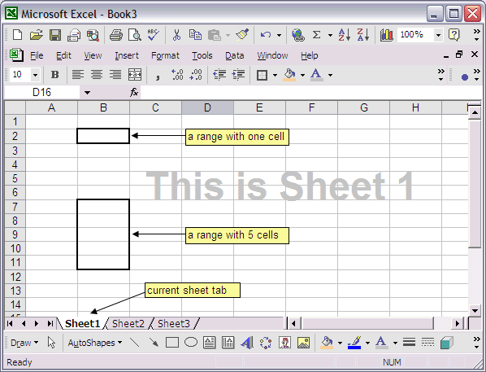

Return to Top of Page

Workbook and Worksheet Object
A workbook is the same as an Excel file. The Workbook collection contains all the workbooks that are currently opened. Inside of a workbook contains at least one worksheet. In VBA, a worksheet can be referenced as followed:
Worksheets("Sheet1")
Worksheets("Sheet1") is the worksheet that named "Sheet1."
Another way to refer to a worksheet is to use number index like the following:
Worksheets(1)
The above refers to the first worksheet in the collection.
* Note that Worksheets(1) is not necessary the same sheet as Worksheets("Sheet1").
Sheets is a collection of worksheets and chart sheets (if present). A sheet can be indexed just like a worksheet. Sheets(1) is the first sheet in the workbook.
To refer sheets (or other objects) with the same name, you have to qualify the object. For example:
Workbooks("Book1").Worksheets("Sheet1")
Workbooks("Book2").Worksheets("Sheet1")
If the object is not qualified, the active or the current object (for example workbook or worksheet) is used.
The sheet tab on the buttom the spreadsheet (worksheet) shows which sheet is active. As the figure below shows, the active sheet is "Sheet1" (show in bold font and white background).
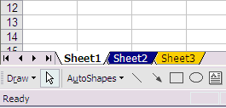
* You can change the color of the sheet tabs by right click the tab, choose Tab Color, then select the color for the tab.
The sub routine below shows the name of each sheet in the current opened workbook. You can use For Each...Next loop to loop throgh the Worksheets collection.
Sub ShowWorkSheets()
Dim mySheet As Worksheet
For Each mySheet In Worksheets
MsgBox mySheet.Name
Next mySheet
End Sub

Return to Top of Page

Range Object and Cells Property
Range represents a cell, a row, a column, a selection of cells containing one or more contiguous blocks of cells, or a 3-D range. We will show you some examples on how Range object can be used.
The following example places text "AB" in range A1:B5, on Sheet2.
Worksheets("Sheet2").Range("A1:B5") = "AB"

: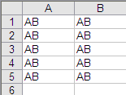
Note that, Worksheets.Range("A1", "B5") = "AB" will yield the same result as the above example.
The following place "AAA" on cell A1, A3, and A5 on Sheet2.
Worksheets("Sheet2").Range("A1, A3, A5") = "AAA"

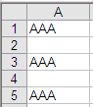
Range object has a Cells property. This property is used in every VBA projects on this website (very important). The Cells property takes one or two indexes as its parameters.
For example,
Cells(index) or Cells(row, column)
where row is the row index and column is the column index.
The following three statements are interchangable:
ActiveSheet.Range.Cells(1,1)
Range.Cells(1,1)
Cells(1,1)
The following returns the same outcome:
Range("A1") = 123 and Cells(1,1) = 123
The following puts "XYZ" on Cells(1,12) or Range("L1") assume cell A1 is the current cell:
Cells(12) = "XYZ"
The following puts "XYZ" on cell C3:
Range("B1:F5").cells(12) = "ZYZ"

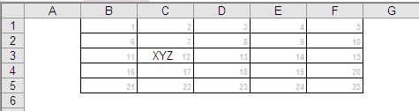
* The small gray number on each of the cells is just for reference purpose only. They are used to show how the cells are indexed within the range.
Here is a sub routine that prints the corresponding row and column index from A1 to E5.
Sub CellsExample()
For i = 1 To 5
For j = 1 To 5
Cells(i, j) = "Row " & i & " Col " & j
Next j
Next i
End Sub

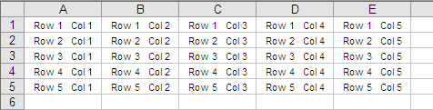
Range object has an Offset property that can be very handy when one wants to move the active cell around. The following examples demostrate how the Offset property can be implemented (assume the current cell before the move is E5):
ActiveCell.Offset(1,0) = 1 Place a "1" one row under E5 (on E6)
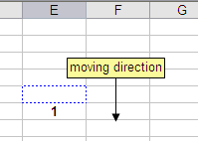
ActiveCell.Offset(0,1) = 1 Place a "1" one column to the right of E5 (on F5)
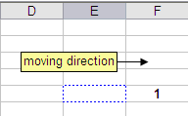
ActiveCell.Offset(0,-3) = 1 Place a "1" three columns to the left of E5 (on B5)

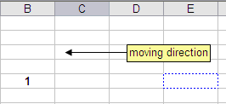

Return to Top Page

Methods and Properties
Each object contains its own methods and properties.
A Property represents a built-in or user-defined characteristic of the object. A method is an action that you perform with an object. Below are examples of a method and a property for the Workbook Object:
Workbooks.Close
Close method close the active workbook

Workbooks.Count
Count property returns the number of workbooks that are currently opened
Some objects have default properties. For example, Range's default property is Value.
The following yields the same outcome.
Range("A1") = 1 and Range("A1").Value = 1
Here are examples on how to set and to get a Range property value:
The following sets the value of range A1 or Cells(1,1) as "2005". It actually prints "2005" on A1.
Range("A1").Value = 2005
The following gets the value from range A1 or Cells(1,1).
X = Range("A1").Value
Method can be used with or without argument(s). The following two examples demostrate this behavior.
Methods That Take No Arguments:
Worksheets("Sheet").Column("A:B").AutoFit
Methods That Take Arguments:
Worksheets("Sheet1").Range("A1:A10").Sort _
Worksheets("Sheet1").Range("A1")
Worksheets("Sheet1").Range("A1") is the Key (or column) to sort by.

Return to Top of Page

Assigning Object Variables and Using Named Argument
Sometime a method takes more than one argument. For example, the Open method for the Workbook
object, takes 12 arguments. To open a workbook with password protection, you would need to write the following code:
Workbooks.Open "Book1.xls", , , ,"pswd"
Since this method takes so many arguments, it is easy to misplace the password argument. To
overcome this potential problem, one can use named arguments like the following example:
Workbook.Open fileName:="Book1.xls", password:="pswd"
You can also assign an object to an object variable using the Set Statement.
For example:
Dim myRange as Range
Set myRange = Range("A1:A10")

